Leak Detection Methods

Technician Training Manual

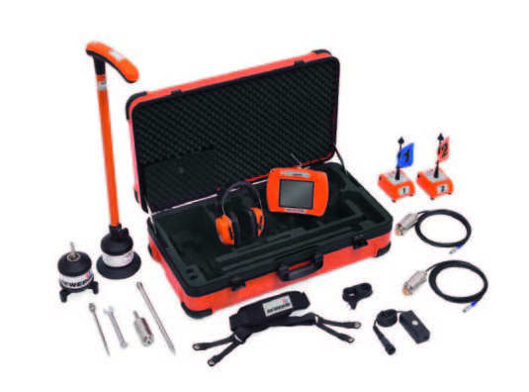

OVERVIEW

🛠️ Introduction to Leak Detection Methods
Leak detection is a critical process in identifying and resolving unwanted water ingress or loss within a building or pressurized plumbing system. Technicians use a combination of specialized techniques, tools, and diagnostic procedures to accurately locate leaks with minimal disruption to surrounding structures.
This training manual introduces the four fundamental methods commonly used in professional leak detection. Each method is selected based on the system type, material, accessibility, and the suspected nature of the leak.

🔎 Core Leak Detection Methods Covered in This Manual
- Flood Testing
Flood tests are used to verify the integrity of waterproofing membranes in wet areas such as showers, balconies, rooftops, and wet rooms. The test involves temporarily damming the area and filling it with water to monitor for leakage over time.
- Tracer Gas & Pressure Testing
This method involves pressurizing a plumbing line with either air or a non-toxic tracer gas mixture (typically hydrogen and nitrogen). A sensitive gas detector is then used to locate escaping gas, while pressure drops indicate the presence of a leak.
- Moisture Detection
Moisture meters and thermal imaging cameras are used to detect elevated moisture levels in materials like walls, floors, and ceilings. These tools help trace hidden leaks, assess water migration paths, and identify areas requiring further investigation.
- Acoustic Correlation Testing
Acoustic correlators are advanced devices that analyze the sound generated by pressurized water escaping from a pipe. By placing sensors on either side of a suspected leak, the system calculates the leak’s location based on the time delay and frequency of the noise.

INDEX

1. 🌊 Flood Testing

Purpose:
To verify the integrity of waterproofing membranes in wet areas (e.g., showers, balconies, rooftops) by observing whether standing water results in leakage.

Tools & Materials:
- Water supply (hose or bucket)
- Temporary damming materials (foam, sandbags, putty)
- Measuring tape or ruler
- Waterproof marker or tape
- Timer or stopwatch
- Access to ceilings/walls below

2. 🧪 Tracer Gas & Pressure Testing

Purpose:
To locate leaks in closed plumbing systems using pressure loss detection and gas tracing techniques.

Tools & Materials:
- Tracer gas (hydrogen/nitrogen mix)
- Pressure gauge
- Electronic gas detector
- Isolation valves
- Hoses and adaptors
3. 🌡️ Moisture Detection

Purpose:
To identify areas of high moisture content that indicate leaks, water migration, or dampness.

Tools & Materials:
- Moisture meters (pin-type and pinless)
- Thermal imaging camera
- Hygrometer (optional)
- Flashlight and access panels

4. 🎧 Acoustic Correlation Testing

Purpose:
To pinpoint leaks in pressurized pipe systems by analyzing the time delay of leak noise between sensors.

Tools & Materials:
- Acoustic correlator
- Pipe clamps/sensors
- Measuring tape
- Pipe layout map (if available)

5. 🏊 Swimming Pool Leak Detection

Purpose:
To locate leaks in swimming pools caused by structural cracks, plumbing line faults, or leaking fittings and accessories.

Tools & Materials:
- Dye test kit
- Pressure testing plugs and gauges
- Electronic listening devices
- Underwater microphone (hydrophone)
- Pool leak detection syringe and goggles

FLOOD TESTING

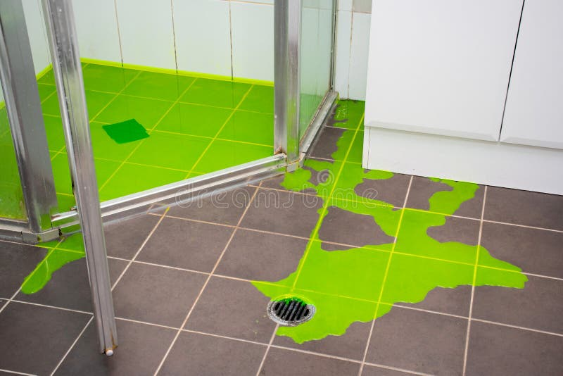

✅ PURPOSE OF A FLOOD TEST
- To verify the integrity of waterproofing before construction proceeds.
- To identify leaks in membranes, joints, penetrations (like pipes or drains), or slab transitions.

🔧 TOOLS & MATERIALS REQUIRED
- Water supply (hose, buckets, etc.)
- Temporary damming materials (e.g., sandbags, inflatable dams, prefabricated flood dams)
- Ruler or measuring tape (to measure water depth)
- Marking tape or chalk
- Stopwatch or timer
- Access to below or adjacent areas (for visual inspection of leakage)
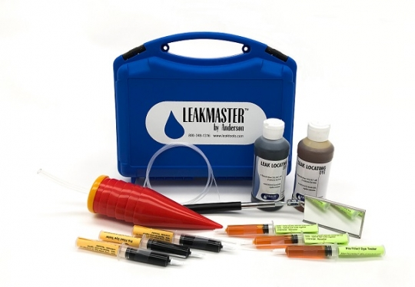

🧪 STEP-BY-STEP PROCEDURE

1. Preparation
- Ensure the area has a completed waterproofing system that is cured and ready to test (usually 24–72 hours after application depending on the product).
- Clean the area—remove debris, dust, and construction waste that could block drainage or give false indications of leaks.
- Seal off any active drains or outlets using mechanical plugs, duct tape, or inflatable test plugs to prevent water from escaping.

2. Damming the Area
- Create a watertight dam around the perimeter of the area to be tested.
- Height of the dam should be at least 2 inches (50 mm) above the surface or the expected water level, as per standards like ASTM D5957 or ASTM D8231.
- Dams must be stable and not allow seepage or bypass.
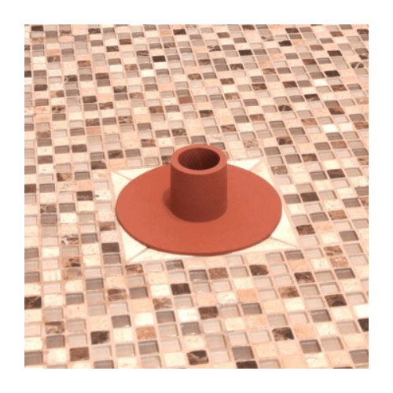

SHOWER PLUG FOR TESTING

3. Filling with Water
- Slowly fill the area with clean water until it reaches a specified depth—typically 25 mm to 50 mm (1 to 2 inches) above the lowest point.
- Use a measuring stick or tape to document the starting depth.
- Mark the high water line visibly (tape or pencil mark).

4. Observation Period
- The area remains flooded for at least 24 hours, though shorter periods (2–6 hours) are sometimes used for small or low-risk installations.
- Monitor both the water level (for drop in height) and below or adjacent areas for visible signs of leakage (e.g., damp spots, dripping, water stains).
- A drop in water level indicates either a leak or evaporation.

5. Leak Detection
- If a drop is noted, inspect the underside or surrounding areas to pinpoint the leak.
- Moisture meters, infrared cameras, or dye can be used to help track slow or hidden leaks.
- Mark any leak locations and document findings (photos, notes).

6. Completion
- Once the test period ends and no leaks are found, drain the water.
- Remove the temporary dams and drain plugs.
- Allow the area to dry completely before proceeding with tiling or finishing work.
- If leaks are found, repair the waterproofing system and retest.

🧑‍🔧 SAFETY & BEST PRACTICES
- Never leave a flood test unattended if the area below is occupied or sensitive to water damage.
- Account for evaporation loss if conducting long tests in hot or windy environments (can be up to 3–5 mm/day). Use covered containers as control measurements to compare.
- Be cautious on elevated structures—excessive water weight can exceed load limits.

🧪 FLOOD TEST PROCEDURE – SHOWER APPLICATION

✅ PURPOSE OF A FLOOD TEST
- To verify the integrity of waterproofing before construction proceeds.
- To identify leaks in membranes, joints, penetrations (e.g., pipes or drains), or slab transitions.

🔧 TOOLS & MATERIALS REQUIRED
- Water supply (hose, buckets, etc.)
- Temporary damming materials (e.g., sandbags, inflatable dams, foam blocks)
- Ruler or measuring tape (to measure water depth)
- Marking tape, chalk, or waterproof marker
- Stopwatch or timer
- Access to below or adjacent rooms for visual inspection
- Moisture meter (recommended)
- Flashlight or inspection light

🧪 STEP-BY-STEP PROCEDURE (GENERAL)

1. PREPARATION
- Confirm the waterproofing system is fully cured (typically 24–72 hours post-application).
- Clean the test area—remove dust, debris, or materials that could interfere with observation.
- Seal all active drains or outlets with plugs below weep holes (if applicable).

2. DAMMING THE AREA
- Install a watertight dam across the shower threshold using damming putty, foam dam blocks, or similar.
- Dam height should be at least 2 inches (50 mm) above the floor surface.
- Ensure the dam is secure and will not leak or move during testing.

3. FILLING WITH WATER
- Slowly fill the base of the shower with clean water to the required depth (about 2 inches).
- Use a tape or marker to visibly mark the waterline.
- Record the initial depth using a measuring tape or ruler.

4. OBSERVATION PERIOD (Typically 24 Hours)
- Monitor for:
  - Water level drop (measured over time)
  - Water stains or dampness in surrounding or lower-level rooms
- Use a moisture meter or infrared camera for difficult-to-see leaks.
- Expect some minor evaporation (3–5 mm/day), especially in dry, windy conditions.

5. LEAK DETECTION
- If a drop in water level is observed:
  - Inspect below and around the test area for leak evidence.
  - Use inspection tools to trace the source (e.g., dye or camera).
  - Document all leak locations with photos and notes.
  - Mark defects for repair.

6. COMPLETION
- Drain the water from the shower base.
- Remove all dams and drain plugs.
- Allow the area to dry thoroughly.
- If leaks were found:
  - Repair the affected waterproofing.
  - Repeat the flood test to confirm the repair is effective.

🚿 SHOWER-SPECIFIC OBSERVATION POINTS

1. PRE-TEST INSPECTION
- ✅ Hairline cracks in tile or grout—especially near corners, seams, and around drains
- ✅ Missing, cracked, or hollow grout
- ✅ Improper slope (look for flat spots or back-pitching away from the drain)
- ✅ Transition areas (e.g., floor-to-wall junctions) for signs of poor membrane adhesion or failure

2. DURING TEST OBSERVATION
- ✅ Measure water level periodically to detect a drop
- ✅ Check adjacent walls or lower rooms for staining or dampness
- ✅ Identify pooling water on the shower floor (indicates insufficient slope)
- ✅ Inspect penetrations (e.g., shower arm, valve opening) for leakage

3. POST-TEST INSPECTION
- ✅ Drywall, baseboards, flooring nearby—check for water damage
- ✅ Tile movement or hollow sound—may indicate water infiltration under tiles
- ✅ New cracks or grout failure after soaking period

🧑‍🔧 SAFETY & BEST PRACTICES
- Do not leave flood tests unattended in occupied or finished areas.
- Use a control container (bucket of water nearby) to measure evaporation rate during testing.
- For multi-story or suspended floors, consult a structural engineer if unsure about load-bearing capacity.
- Document the test with photos, depth readings, and timestamps for quality assurance.

TRACER GAS AND PRESSURE TESTING

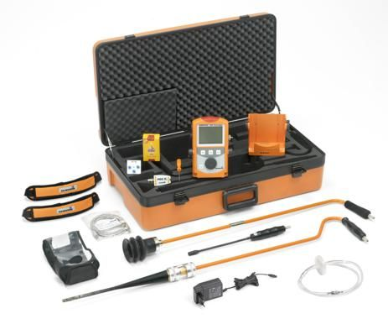

📌 Purpose:
To locate hidden or underground leaks in closed plumbing systems (especially where water leaks are not visible) by identifying pressure loss and tracing the escape of hydrogen gas.

🛠️ Tools & Materials Required:
- Tracer Gas Cylinder: A safe, non-toxic mix of 95% nitrogen and 5% hydrogen (forming gas)
- Pressure Gauge: For continuous pressure monitoring (ensure it is calibrated)
- Electronic Hydrogen Detector (Sniffer): Highly sensitive to hydrogen for pinpointing leak locations
- Isolation Valves/Plugs: To isolate specific pipe sections (suction or return lines)
- Hoses and Adaptors: For secure connection to plumbing systems
- Regulator: To safely control the flow and pressure of tracer gas
- Water Trap Bucket (optional): To observe water displacement
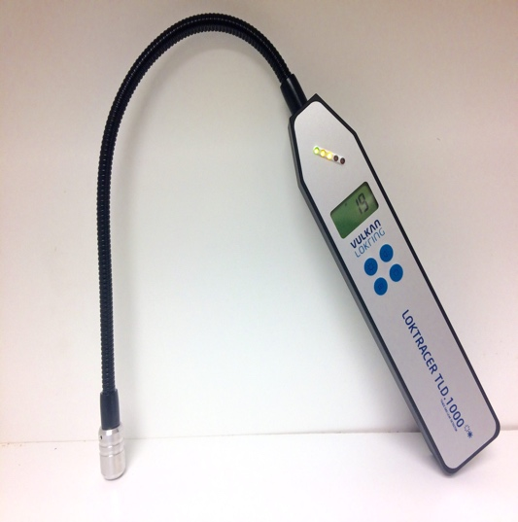
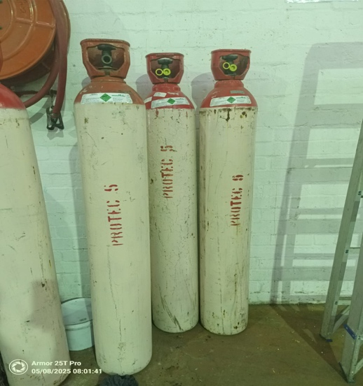

🔧 Step-by-Step Procedure:

🔹 1. Preparation
- Turn off all pumps, water feeds, and valves connected to the test section.
- Identify the section to be tested (e.g., suction or return side of a pool, household pipe loop).
- Plug or cap all outlets in the isolated section using expansion plugs or valve caps.
- Ensure no residual water in the section to avoid blocking the gas escape.

🔹 2. Connection Setup
- Connect the tracer gas cylinder to the test port or pipe via a regulator and hose.
- Connect a pressure gauge to monitor the line pressure.
- Double-check all seals for tightness.

🔹 3. Apply Tracer Gas
- Slowly introduce tracer gas into the system, increasing pressure up to but not exceeding 1 bar (14.5 PSI).
- Monitor the pressure for 15–30 minutes:
  - No pressure drop = No leak.
  - Steady pressure drop = Leak present.

🔹 4. Leak Detection
- After confirming a pressure drop, use the hydrogen sniffer to scan:
  - Along the surface of the ground (for underground leaks)
  - Inside walls, floors, or near pipe paths (for indoor leaks)
- Move the sniffer slowly and close to the surface; hydrogen rises quickly.
- Look for peaks in readings or an audible alarm to indicate the leak location.

🔹 5. Pinpointing the Leak
- Once a leak is detected, mark the area clearly.
- For large or complex systems, segment testing may be required to isolate leak locations.

✅ Best Practices:
- Always ventilate the area during testing for safety.
- Never exceed safe pressure limits; refer to manufacturer specs for the system being tested.
- Avoid testing in high-wind areas, as hydrogen disperses quickly and may affect readings.
- Do not smoke or allow open flames nearby—hydrogen is flammable in high concentrations.
- Perform testing after-hours or off-peak when no other water usage interferes.

⚠️ Limitations:
- Hydrogen detectors cannot detect leaks in non-accessible buried pipes if gas cannot rise to the surface.
- Gas may follow underground paths and emerge far from the actual leak point—use in combination with acoustic detection for confirmation.
- Best suited for pressurized plumbing systems, not gravity-fed systems.

MOISTURE DETECTION

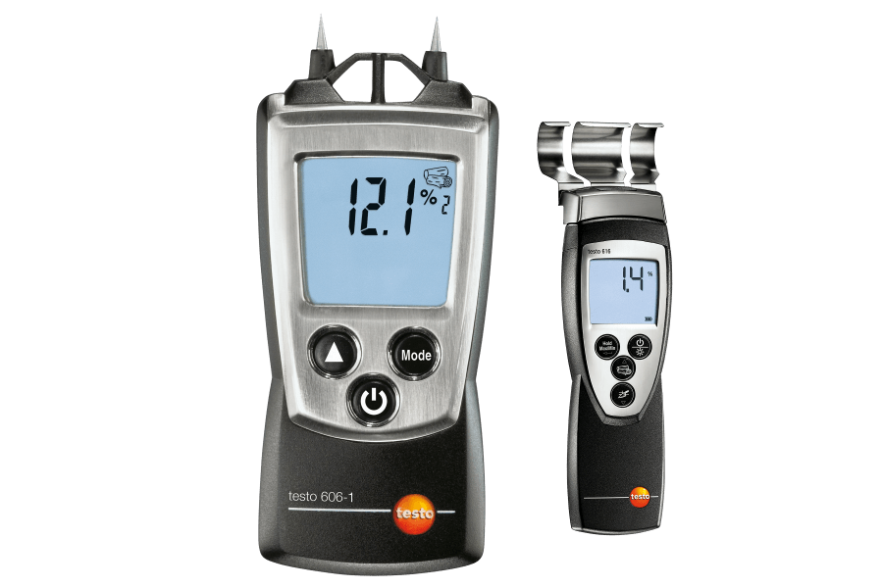

3. 🌡️ Moisture Detection
📌 Purpose:
To identify hidden moisture, damp patches, and water intrusion that may indicate active leaks, past water damage, or areas at risk for mold growth. Moisture detection is particularly important for walls, floors, ceilings, and enclosed areas where water is not visibly present.

🛠️ Tools & Materials:
- Moisture Meters:
  - Pin-Type (penetrates surfaces to measure internal moisture)
  - Pinless/Capacitive (non-invasive surface scanning)
- Thermal Imaging Camera: Detects temperature differentials caused by evaporative cooling or wet materials.
- Hygrometer (optional): Measures relative humidity to assess indoor moisture levels.
- Flashlight: For visual inspections in dark corners, behind appliances, etc.
- Access Panels: For inspecting behind drywall, under cupboards, or inside wall cavities.

🔧 Step-by-Step Procedure:

🔹 1. Initial Visual Inspection
- Use a flashlight to look for visual signs of water damage:
  - Discoloration (yellow/brown stains)
  - Peeling paint or bubbling plaster
  - Mold or mildew
  - Warped surfaces (flooring, cabinets)

🔹 2. Use of Moisture Meter
Pin-Type Meter:
- Insert the metal pins into the suspected material (wood, drywall, plaster).
- Take multiple readings at different heights and areas.
- Readings above 15–17% in drywall or 20% in timber often indicate moisture problems.
Pinless Meter:
- Place flat on the surface and slowly move it in a grid pattern.
- Good for quick surveys and sensitive finishes where pin insertion is not allowed.
- Compare baseline dry readings with suspect areas.

🔹 3. Thermal Imaging Scan
- Scan walls, ceilings, and floors using the infrared camera.
- Look for cooler blue or purple areas indicating evaporative cooling (a sign of moisture).
- Cross-check thermal anomalies with moisture meter readings to confirm water presence.

🔹 4. Humidity Measurement (Optional)
- Use a hygrometer to measure ambient relative humidity in the area.
- Humidity above 60% RH indoors may support mold growth and suggest excess moisture.

🔹 5. Access Panel Checks (if applicable)
- Open panels or remove kickboards to inspect hidden areas behind kitchen cupboards, under sinks, or inside wall cavities.
- Use flashlight and moisture meter to test insulation, wall studs, or floor joists.

✅ Best Practices:
- Always calibrate moisture meters before use.
- Compare readings to known dry areas to establish a baseline.
- Document all readings, photos from thermal imaging, and visual observations.
- Conduct testing in dry weather if possible—high ambient humidity can skew readings.

⚠️ Limitations:
- Pinless meters may not detect moisture in deep or dense materials.
- Thermal imaging does not confirm moisture—only temperature differences (always confirm with a moisture meter).
- Pin-type meters leave small holes in surfaces—use with caution on finished materials.

ACCOUSTIC CORRELATION TESTING

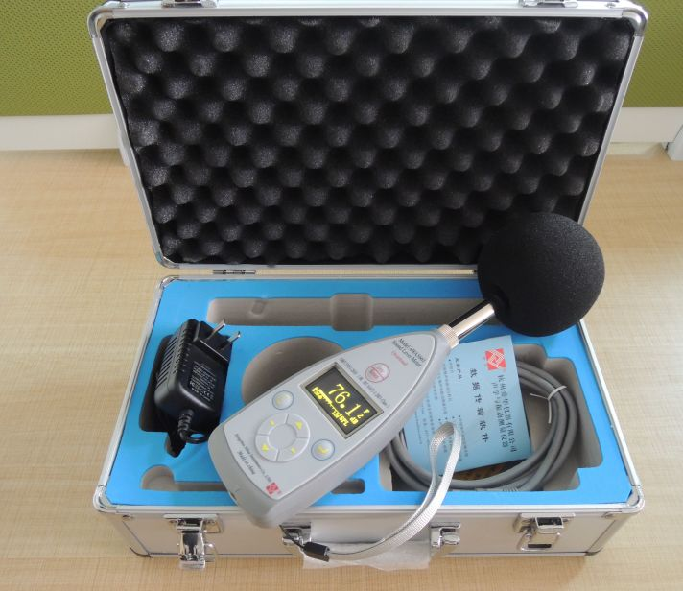

📌 Purpose:
To pinpoint the exact location of leaks in pressurized underground or concealed pipe systems by analyzing the time difference in leak noise detection between two or more sensors placed along the pipeline. This method is highly accurate and minimizes unnecessary digging or damage.

🛠️ Tools & Materials:
- Acoustic Correlator (includes sensors and processing unit)
- Pipe Clamps or Surface Sensors (to attach to exposed sections of the pipeline)
- Measuring Tape or Laser Distance Measurer
- Pipe Layout Map or Schematic (optional but helpful for sensor placement and data input)

🔧 Step-by-Step Procedure:

🔹 1. Preparation
- Review any available plans or schematics to identify the suspected leak zone and accessible pipe endpoints.
- Locate accessible points such as valves, meters, or exposed fittings where sensors can be attached.
- Ensure the pipeline is pressurized (i.e., system active or artificially pressurized using air or water). The leak needs to be active to generate sound.

🔹 2. Sensor Placement
- Attach Sensor A and Sensor B to the pipe at two known points on either side of the suspected leak area (e.g., 15–30 meters apart).
- Secure with clamps and ensure good contact with the pipe (metal-to-metal contact for metal pipes).
- Measure the exact distance between the two sensors using a tape measure and record it.

🔹 3. Input Data into the Correlator
- Input the pipe material (e.g., PVC, copper, HDPE), internal diameter, and sensor spacing into the correlator device.
- This information calibrates the correlator for accurate time/distance calculations based on sound travel speed in the pipe material.

🔹 4. Noise Capture & Analysis
- Start the correlator and allow it to record the sound waves (leak noise) received from both sensors.
- The device will analyze the time delay in which the leak noise reaches each sensor.
- The correlator then uses this delay, along with pipe data, to calculate the leak location as a distance from each sensor.

🔹 5. Pinpoint the Leak Location
- The correlator will display a distance (e.g., “Leak located 7.2m from Sensor A”).
- Mark the ground or surface directly above the calculated point for further inspection or targeted excavation.

✅ Best Practices:
- Perform the test at night or during low-noise periods to reduce ambient noise interference.
- For plastic pipes (which carry sound poorly), ensure high sensitivity settings or use an amplifier.
- Use water pressure if possible—leak sounds tend to be louder in water-filled pipes than in air-pressurized ones.

⚠️ Limitations:
- Accurate pipe layout and distance measurements are critical; errors will affect location precision.
- Very small leaks or those in low-pressure systems may produce insufficient noise.
- Background vibrations (traffic, machinery) can interfere with readings—choose a quiet testing time.

SWIMMING POOL LEAK DETECTION

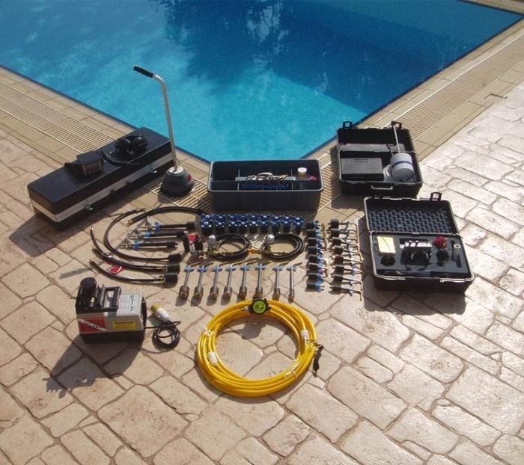

📌 Purpose:
To accurately identify and locate leaks in swimming pools, which may stem from structural damage, faulty plumbing, or defective fittings/accessories. This is critical for water conservation, structural integrity, and cost-effective repair planning.

🛠️ Tools & Materials:
- Dye Test Kit (dye syringe, goggles)
- Pressure Testing Plugs and Gauges
- Electronic Listening Devices
- Underwater Microphone (Hydrophone)
- Leak Detection Syringe
- Diver’s Equipment (mask/snorkel or SCUBA, if needed)

🔧 Step-by-Step Procedures:

🔹 1. Initial Visual Inspection
- Check the water level for unexplained drops over time.
- Examine the skimmer, return inlets, main drain, lights, and shell for visible cracks, stains, or unusual wear.
- Ask the pool owner questions about when the leak started, pump cycle behavior, or if any areas seem wetter than usual.

🔹 2. Dye Testing (for structural and fitting leaks)
- Turn off the pool pump and allow water to become still.
- Put on goggles and use the dye syringe to slowly release dye near suspected leak points:
  - Skimmer throat
  - Return jets
  - Steps, cracks in shell
  - Underwater lights and main drain
- Watch for dye being drawn into a crack or seam, which confirms a leak.

🔹 3. Pressure Testing (for pool plumbing)
- Plug the return and suction lines using expansion plugs inside the pool.
- Use pressure testing gauges at the pump pad:
  - Apply low-pressure air or water (typically 5–10 PSI, never exceed 15 PSI).
  - Monitor the gauge for pressure drops over 15–30 minutes.
  - A drop indicates a leak in that plumbing line.
- Isolate and test lines individually to narrow down the source (skimmer, main drain, return).

🔹 4. Electronic Listening / Acoustic Testing
- Use electronic listening devices or hydrophones to detect the sound of escaping water.
- Ideal in quiet conditions—best performed early morning or night.
- Slowly move the device over:
  - Underground plumbing routes
  - Decking joints
  - Around fittings or shell seams
- A high-pitched hissing or gurgling noise usually pinpoints the leak.

🔹 5. Hydrophone Testing (Advanced)
- Use a hydrophone for precise underwater leak detection.
- Move it slowly around fittings, lights, and floor drains while listening for sound anomalies.
- This method is ideal for vinyl liner pools where visibility may be limited.

✅ Best Practices:
- Measure daily water loss using a bucket test before advanced testing.
- Combine dye testing with pressure testing to confirm structural vs. plumbing issues.
- Document all findings with photos or diagrams to support repair planning or insurance claims.
- Always retest after repairs to confirm the issue has been resolved.

⚠️ Limitations:
- Wind, pump activity, or swimmers can disturb dye tests—always test in still water.
- Multiple leaks can make diagnosis difficult—test systematically.
- Older pools may have fragile fittings or pipes; proceed gently during testing.

